**CTF Topic: SSL Certificate Analysis**

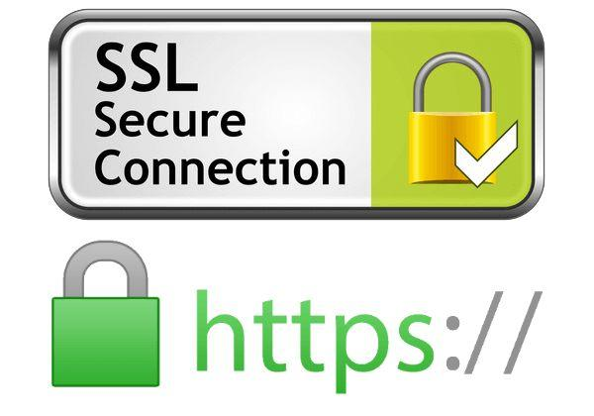

**Introduction**

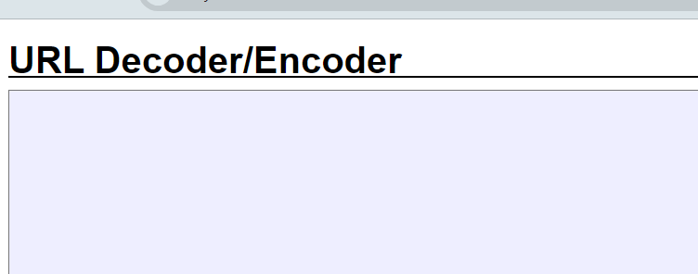

SSL (Secure Sockets Layer) certificates are crucial for securing the communication between a user's browser and the web server. Using SSL Checker tools, one can verify the details and validity of SSL certificates used by a website.

**Tools and Requirements**

Web Browser

Access to [decoder.link](https://decoder.link)

**Scenario**

A security analyst is tasked with verifying the SSL certificate of the website `www.blanxer.com`. The analyst uses the online tool available at decoder.link: <https://decoder.link> to perform the check. Your task is to analyze the results and answer the questions based on the provided information.

**Process to follow while performing CTF**

Step 1: Visit decoder.link: <https://decoder.link>

Step 2: Enter the domain “www.blanxer.com”: <https://www.blanxer.com/>

Step 3: Analyze the result and solve the CTF

**Questions**

Flag 1: What is the serial number of www.blanxer.com?

Answer: 4314671d15499fa0e713c69b18c3e2dd903

Flag 2: Who is the issuer of the SSL certificate for `www.blanxer.com`?

Answer: Let's Encrypt

Flag 3: What is the MD5 Fingerprint of ISRG Root X1?

Answer: C1:E1:FF:07:F9:F6:88:49:82:74:D1:A1:80:53:EA:BF

**Hint**

